Rob & Jody
Sponsored by Farmington & New Durham parks and Recreation
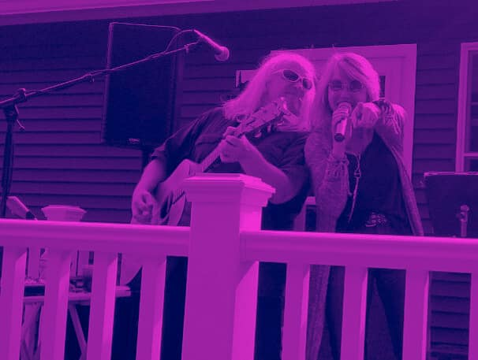
June 11th 4-7pm
Farmington Rec Center
531 Main st. Farmington, NH
Adults 18+
Free Music, Dance & light refreshment provided.

